**EFFECTIVE KNOWLEDGE MANAGEMENT: FROM ARTICLE CREATION TO APPROVAL**

PROJECT DESCRIPTION:

To efficiently create and gain approval for a comprehensive Knowledge Article within the ServiceNow platform, ensuring that the information is accurate, accessible, and beneficial for users seeking solutions or guidance. The project aims to streamline the knowledge management process, enhance user experience, and reduce support ticket volumes by providing readily available, high-quality documentation.

IMPLEMENTATION:

## Activity-1 : Create Users

1. Open service now.
2. Click on All  >> search for users
3. Select Users under system security
4. Click on new
5. Fill the following details to create a new user

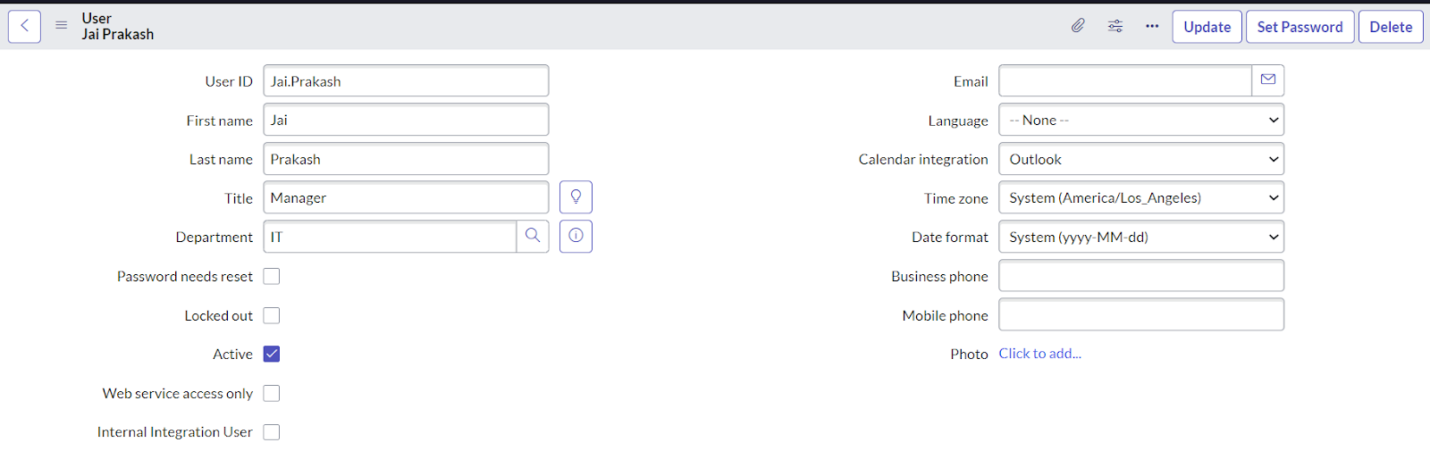

1. Click on Submit.

## Activity - 2: Create Groups

1. Open service now.
2. Click on All  >> search for groups
3. Select groups under system security
4. Click on new
5. Fill the following details to create a new group.

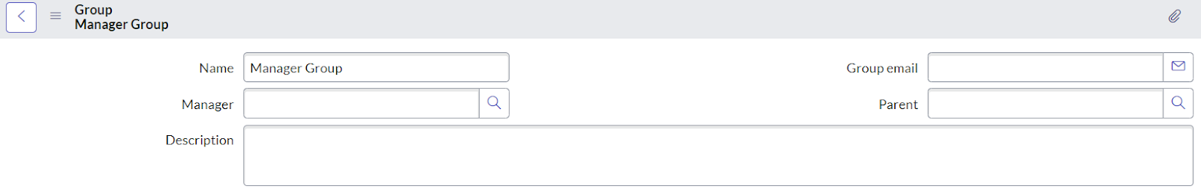

1. Under Group Members, click on edit.
2. Add the user(Jai Prakash) to the Manager Group and click on Save.

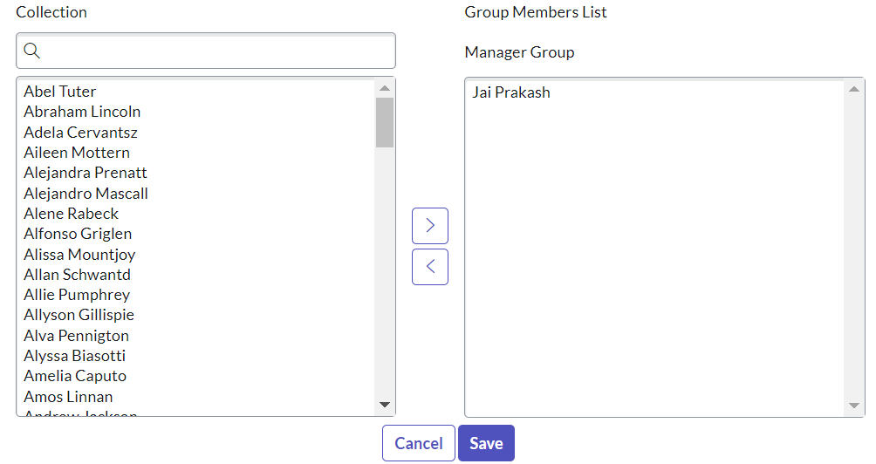

1. It would like below.

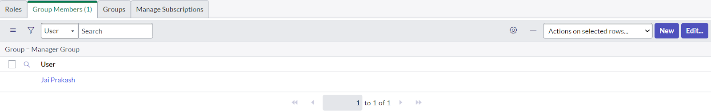

1. Click on save.

## Activity - 3: Create Roles

1. Open service now.
2. Click on All  >> search for roles
3. Select roles under system security
4. Click on new
5. Fill the following details to create a new role

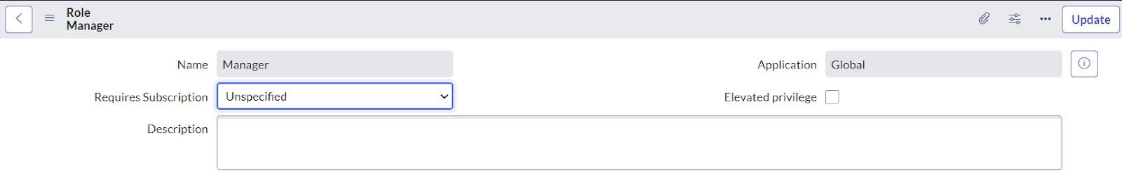

1. Click on submit.

**Activity - 4: Changing the Owner of the Knowledge Base**

1. Go to All >> Search for Knowledge Bases.

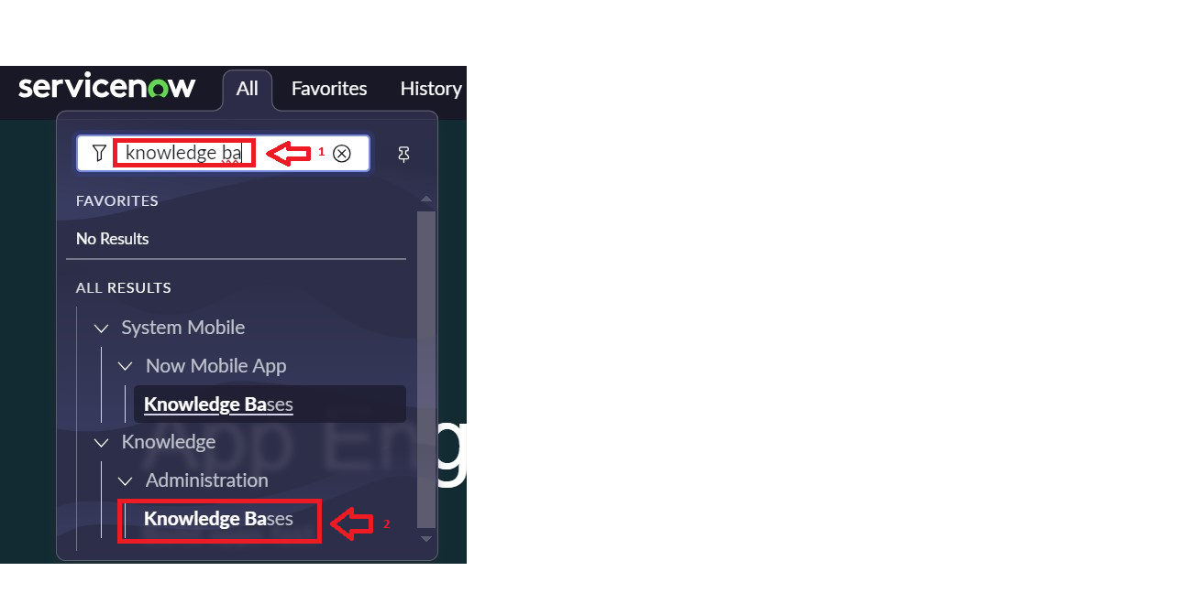

1. Open Knowledge bases and change the of IT from Bernard Laboy to Jai Prakash(To change Owner click on the Name and change it)

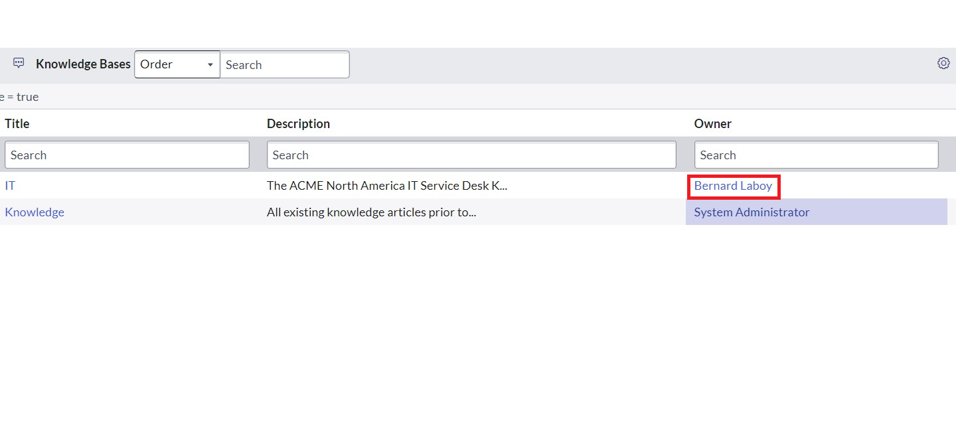

1. It would look like below.

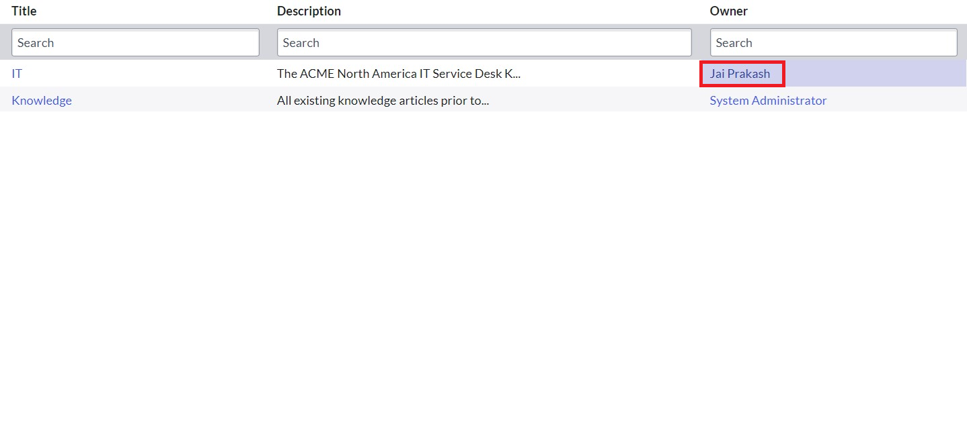

**Activity - 5: Creation of Knowledge Article.**

1. Go to All >> Search for my knowledge Articles.

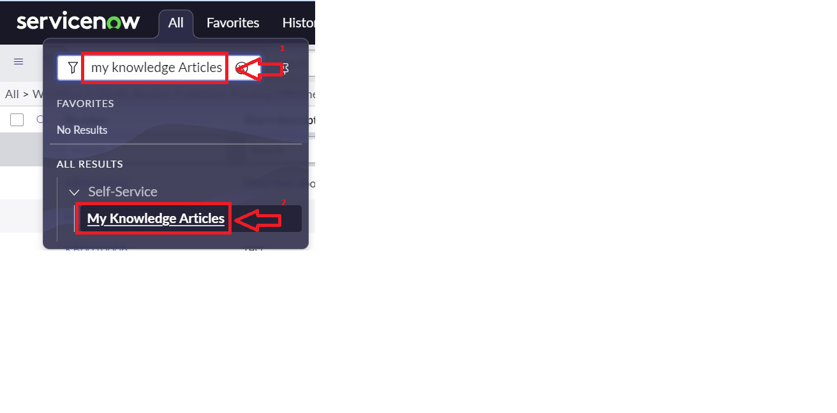

1. Open my knowledge Articles >> Click New.
2. Fill the details as below:

Number : Auto-generated.

Knowledge base : IT

Category : Select any category

Short description : Describes about Cloud Computing. (Give Short description as per  your requirement)

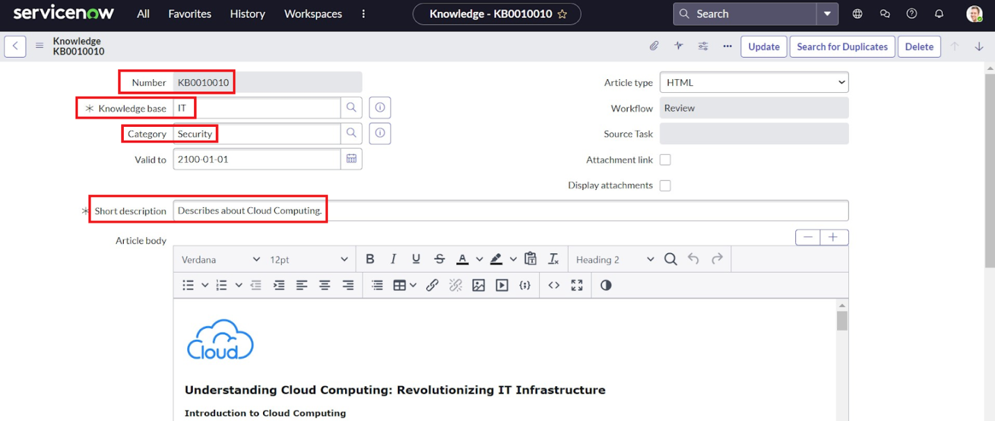

Article body : (paste your knowledge Article here

Result:

1. To verify weather the email is send for approval or not.
2. Go to All, search for emails.
3. Under System logs click on Emails.

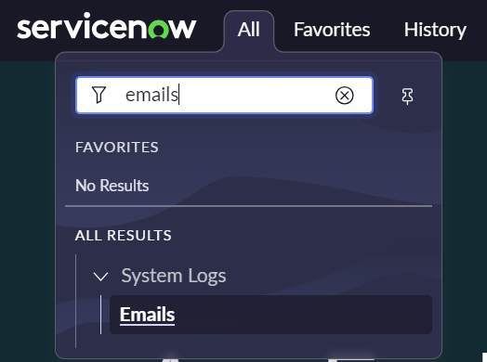

1. There you can see that the email has been sent.

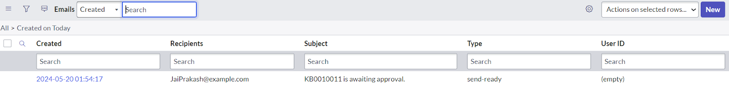

My Output:

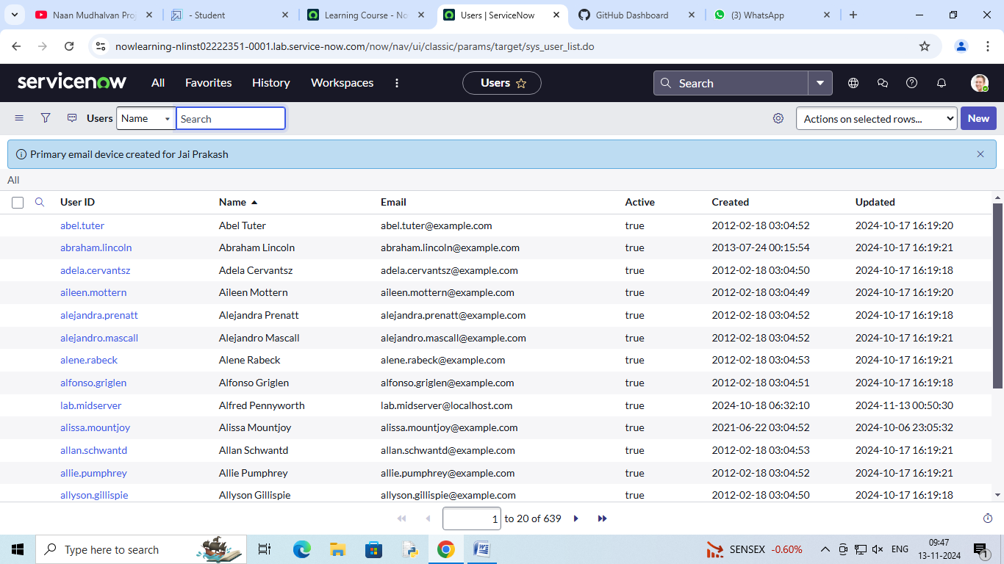

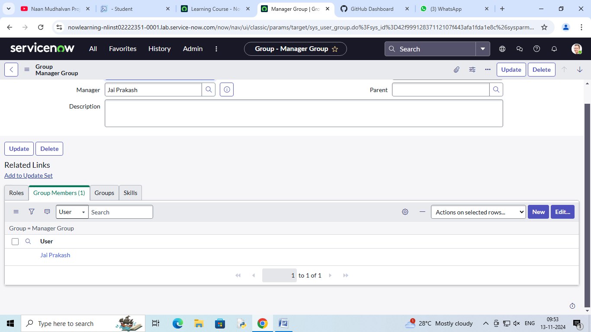

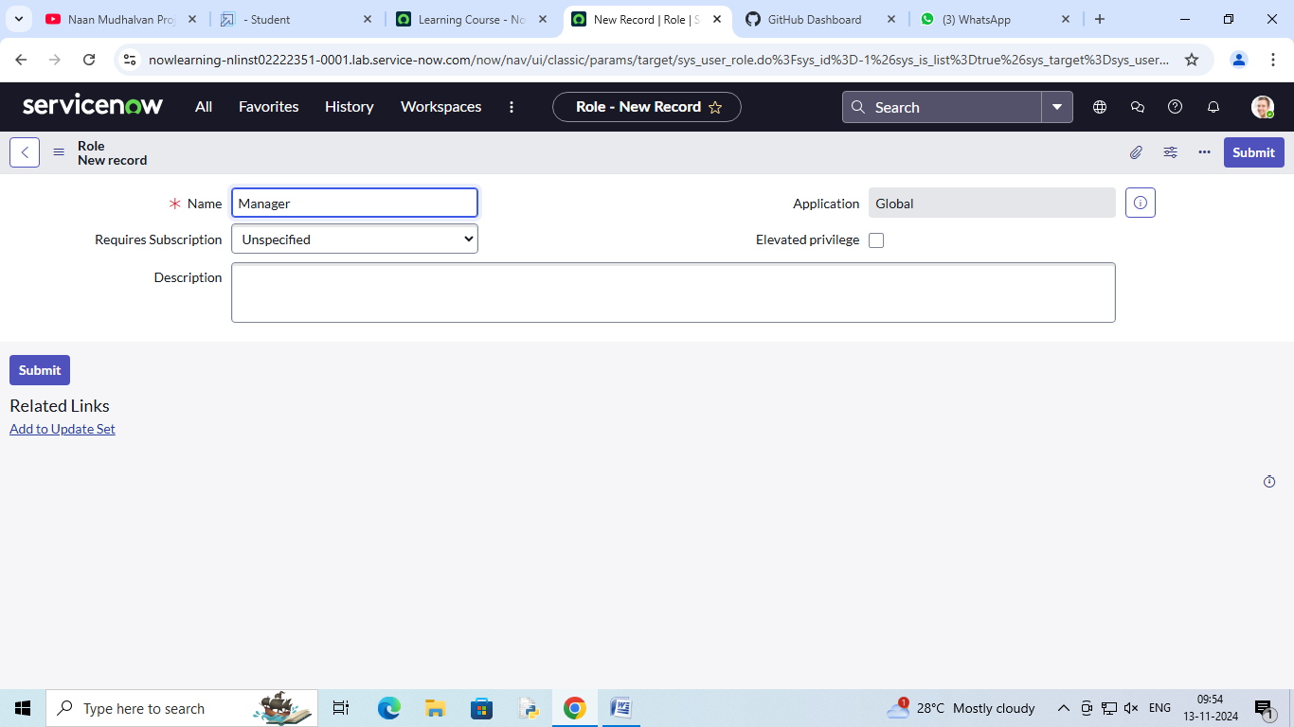

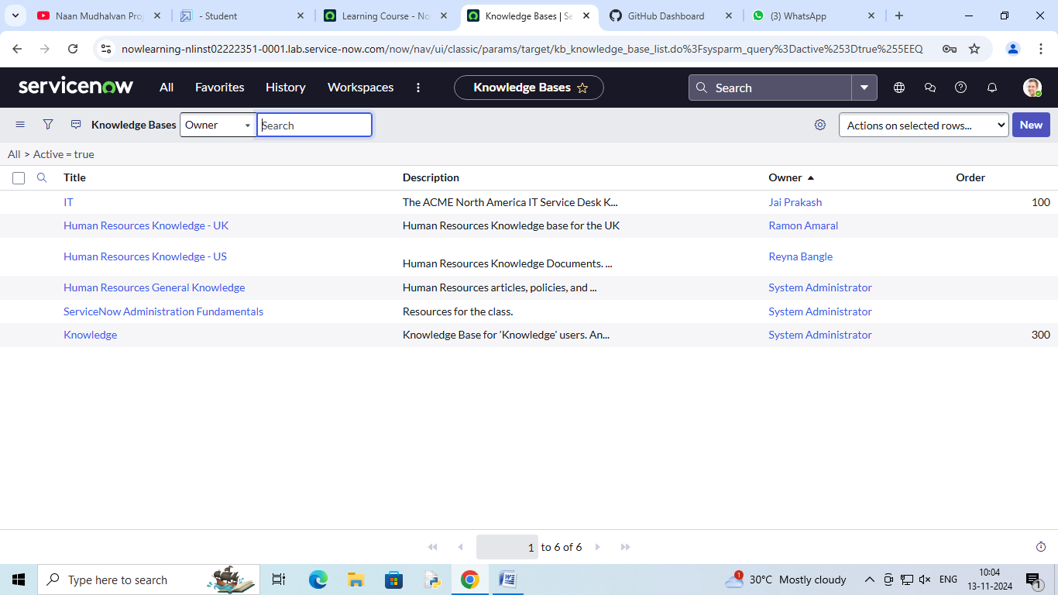

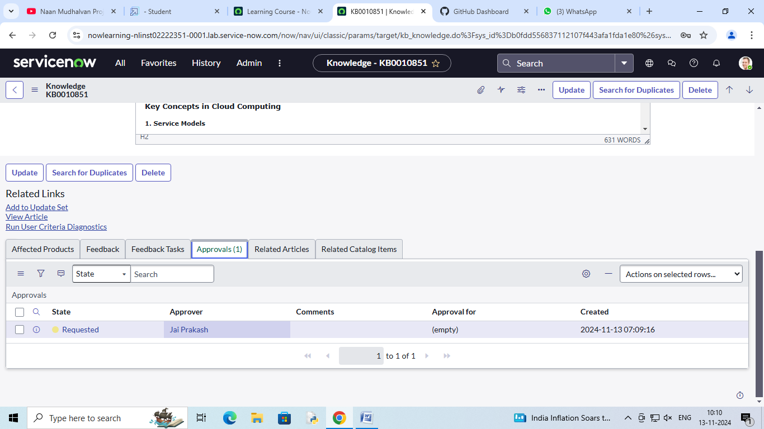

TEAM MEMBERS:

1.AJAY SHARON- [ajaysharon2750@gmail.com](mailto:ajaysharon2750@gmail.com)

2.NAJMUDHEEN KP- najbinhanef@gmail.com

3.JAIKANTH- jaikanthjai048@gmail.com

4.ANSHAD PE- anshadpe349@gmail.com